How can you help at Home?
Personal, Social and Emotional Development:
- Support your child to respond to different activities and events, talking about their feelings.
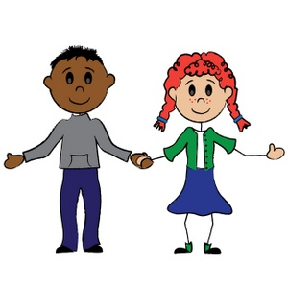
- Play games which encourage sharing and turn-taking which will help your child to build their social skills.
- Encourage discussions about achievements and goals.
- Encourage your child to tolerate delay.

Communication and Language:
- Encourage your child to listen and respond appropriately.
- Encourage your child to engage in conversations with new people.
- Encourage your child to pose questions that use why , how, where, what, when and who.
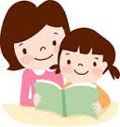
- Take time to listen to your child talking about things they’ve done and answer their questions.

Physical Development:
- Give your child time to experiment with running, jumping, climbing and playing outdoors.
- Share stories about being healthy, choosing the right food, drinking water and getting plenty of sleep.
- Encourage your child to participate in activities such as building, drawing, threading beads, playing with water, malleable materials and construction.
- Encourage and support your child to independently use the toilet.
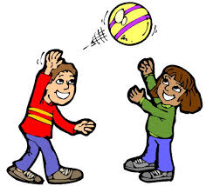

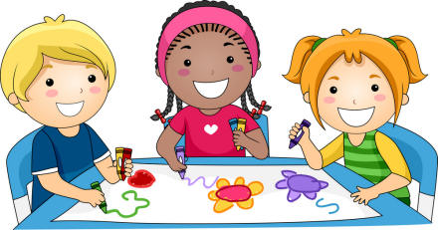
Literacy:
- Share stories and books at home discussing the characters and sequence of events.
- Sing simple familiar rhymes.
- Have fun with chalks, crayons, and whiteboards.
- Look out in the environment for familiar letters and words.
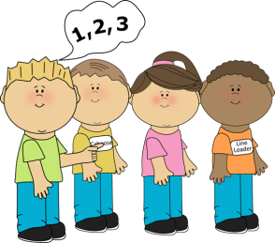
- Make up stories with your child and act out the different roles and plots.
Mathematics:
- Talk about the shapes you can see in the environment.
- Compare things which are heavy and light or long and short.
- Look out for numbers in and out of the home.
- Sing counting songs and rhymes.
- Count, add and subtract anything and everything - socks, cars,

shopping, cutlery, fingers and toes!

Understanding the World:
- Talk with your child about the places they go and things they see in the world around them.
- Answer and encourage questions - What if…? Why do you think…? How did you…?
- Let children join in with everyday activities - washing up, cooking, shopping, helping in the garden...
- Provide lots of opportunities to explore inside and outside in a variety of environments.
Expressive Arts:
- Have junk modelling sessions and see what you can create.
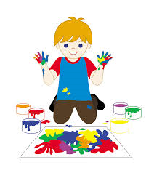
- Paint a picture and not necessarily on a piece of paper.
- Play musical instruments.
- Dance to your favourite music.

