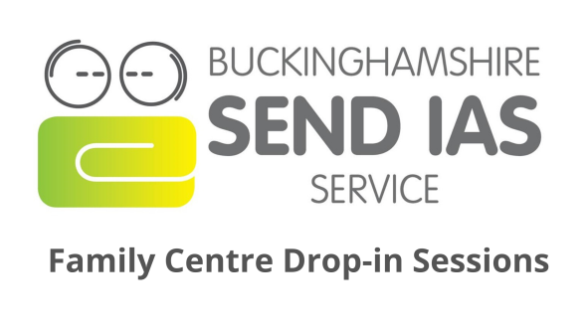

Wednesday 12th February 2020

13:00pm to 15:00pm

Do you have a child with special educational needs? Do you know where to turn to for impartial information, advice and support? Do you live in Buckinghamshire?
Drop-in to meet one of our advisers, find out more about what our service offers and take away an action plan. This is a free drop-in service to provide parents and carers with advice and support.

There are five 20-minute bookable slots over the 2 hour session. You can book a slot on Eventbrite (www.Eventbrite.co.uk) by searching SEND IAS. These will be will be allocated on a first come first serve basis. If there are no slots remaining to book online for your preferred Family Centre, please check availability on Eventbrite at other locations as we will be holding these sessions across various centres in Buckinghamshire.

If you have booked on-line but you are unable to attend, please cancel your booking at the earliest convenience. Thank you.

