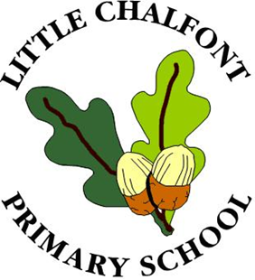

All About
Me

Name:

Dear Parents/Carers,

Please would you take some time to complete this short booklet with your child. It will help yourselves and our staff prepare for your child’s needs and ensure their special interests are planned for.
You can include photos and /or pictures drawn by your child or yourselves.
Please bring this booklet back to the Nursery class on your child’s first day.
Thank you,

Mrs Abadee, Mrs Chester and Mrs Botwright

All about me...
A drawing or photograph of me

My name is:
My date of birth is:

I like to be called:

My brothers and sisters are called:

My pet is a ...

It is called...

Things I like to do:

My favourite toy/activity is:

I can do these things:

I need help with:

Things I would like you to know about me...
Eating
I like to eat
I don’t like to eat
I can’t eat (special dietary requirements)

Feelings
What makes me happy, angry or sad?
How I show these feelings
What helps to calm me down if I am upset

More about me and my Family

People who are special to me:
My family

My special friends

We like to do:

We celebrate occasions such as:

Pictures of people who are important to me...

Things that will help me settle at Nursery...
Please include anything that will help to provide a smooth transition to nursery for your child.

